Women’s Issues Network (WIN)  VICTORY NEWS  December 2018/January 2019, Volume 3, Issue 6  13 Pages  Editor: Rebecca S. Willman  Clark County/Springfield, Ohio | 

Leadership Insights – Trials and Triumphs!
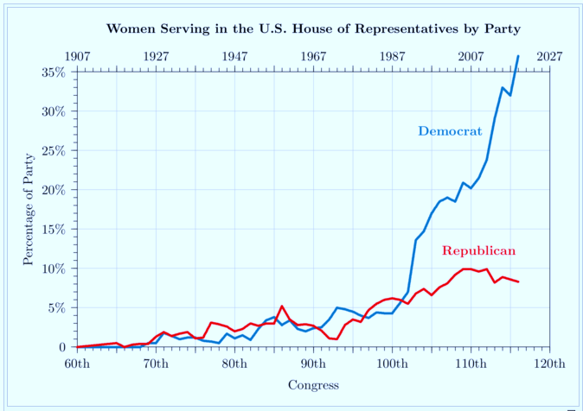
As we end 2018, WIN can look back with pain and pride. While the recent local and state elections were disappointing, historically and nationally, more women stood up, stepped up, ran, and won! In the 65th Congress (1916-1919), .02% women served in congress. The 116th Congress (2019-2021) will be 23.6% women, meaning that of the 535 members of congress (435 in the House, 100 in the Senate), 126 will be women. What party leads the way promoting women leaders. Well, let’s just say, a picture is worth a thousand words.
WIN is proud that our members worked hard this past year to promote Dr. Vanessa Enoch (Ohio 8th Congressional District), Amanda Finfrock, Esq. (Ohio House 79th), and Ann Gorman (Ohio House 74th) in their bids for office. These qualified women candidates made an excellent showing as first-time candidates. And, WIN encourages them to run again! As Senator Brown says, “We’ve got your back!” Members also made phone calls, walked precincts, sent mailers, held meet-and-greets, made campaign contributions and more for our local and state-wide candidates. And, WIN as a group held our annual August Nights, an A to Z (Amanda Finfrock to Zack Space), and Buffalo Wild Wings trivia night fundraisers wherein we raised and then gave away thousands of dollars to viable Democratic candidates.
We can also eagerly look forward to 2019! Yes, the new year signals new beginnings, fresh starts, and renewed commitments. This is true for WIN, too. In January, we will hold elections for president, treasurer, and recording secretary. Those elected to these positions will complete their terms December 31, 2019.
In 2019, WIN will seek to perfect our constitution, pursue deeper engagement with like-minded groups, help women address their concerns as well as promote Democratic ideals and candidates. WIN will continue to promote stable leadership that in turn spurs growth and creates family, community, and national opportunities for all, no matter your age, race, national origin, religion or sexual orientation.

While 2019 is considered an “off” year insofar as elections, given the state of things locally, statewide, and nationally, there are no “off” years. There are several stepping-stone elected offices up-for-grabs in 2019, such as school board, township trustee, village council, and more (see the offices here: https://clark.ohioboe.com/c/PetitionGuide.pdf). Why not have a look and consider running?
Women in leadership have always and will continue to make a positive difference in our communities and in our country. That’s why it is important for you to renew your WIN membership today (due January 2019) or join us as a new member and get involved with a group of dynamic, determined, Democrat women and men who are working hard for a fair shake for all of us—not just the moneyed and named; justice for all—not for only those who can afford it, a healthcare system for people—not for profit; and an education system that works for all students—not just those from privileged backgrounds; workers rights and benefits—which are EARNED benefts, not “entitlements,”and for checks and balances—not just one-party rule.
So go ahead and take a breath and refresh during these last days of 2018, ladies and gentlemen, because your time and talents are needed in 2019 as we in WIN continue to work together to create a progressive and inclusive future for our Clark County Ohio Community, our wonderful state, and our beloved country.
To a strong Democracy, Clark County, State of Ohio, and Nation!
Sue Allen, WIN Acting President and WIN Leadership


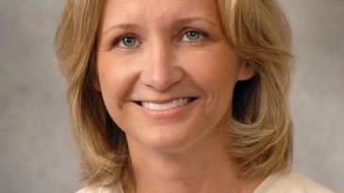

WIN WELCOMES NEW CLARK COUNTY CORONER (Photo: Springfield News-Sun)

On the afternoon of Monday, November 5th, Dr. Susan Brown was sworn in as the new Clark County Coroner by Judge Richard O’Neill. She replaces Dr. Richard Marsh, who retired in October after serving our county in that capacity for 22 years. The Clark County Democratic Party appointed her to that position in October to fill the vacant position until being officially sworn in. They presented Dr. Marsh with a service award for his decades of service to our community.

WIN is so proud of Dr. Brown, as she is not only a woman, but one of just a handful of Democrats to fill county offices. WIN representatives attending the ceremony were Sue Allen, Colleen Buscemi, Cathy Tuckerman, and Becky Willman.

Dr. Brown will serve until at least 2020, when the seat will be up for re-election. An elected coroner serves a 4-year term. She is a native of Cincinnati, but now lives in Clark County.
Left Photo: WIN Members Sue Allen, Colleen Buscemi, and Cathy Tuckerman join Coroner’s Office Investigator Patrick Gleason for the Swearing-in of new Clark County Coroner Dr. Susan Brown. Right Photo: Dr. Brown takes the Oath of Office from Judge Richard O’Neill.




WIN Sponsors Special Program

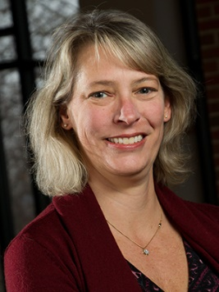
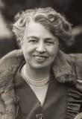

Dr. Mollie Wood The Honorable Eleanor Roosevelt
On the evening of October 11th, WIN sponsored a “Happy Birthday, Eleanor Roosevelt!” educational program about her life on what would have been her 134th birthday. The event was held at Democratic Campaign Headquarters, 40 East High Street. It was free and open to the public.
We were honored to have Dr. Mollie Wood, Chair of the History Department at Wittenberg University, as our speaker. She has a special interest in the life of Mrs. Roosevelt. After her lecture, we celebrated Eleanor’s life with birthday cake.
Dr. Wood focused on Eleanor’s early life, as people generally know more about her role as First Lady when her husband, Franklin Roosevelt, was U.S. President. We learned so much about her that we had not known! For instance, she had lost both her parents at an early age and was sent to an English boarding school in her teens. Even before marrying Franklin, she was a bundle of energy, constantly trying new things and being a staunch feminist a long time before it was called “feminism.”
WIN plans to hold more of these public informational and topical programs in 2019.

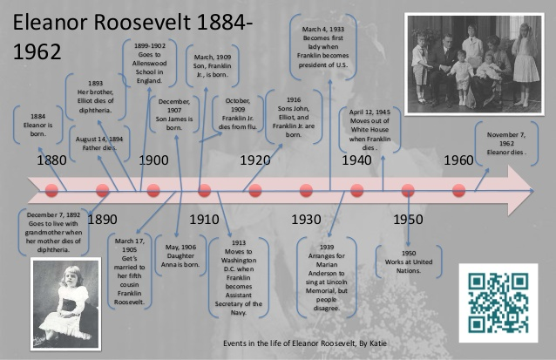

WIN President Cheri Crothers gets the evening started.

LAME DUCK QUACKERY
WIN member David Farrell, who also serves on the staff of the Ohio Democratic Party, is helping spread the word that our current lame duck Ohio Legislature is trying to pull off a couple of fast ones before the end of the year. ODP Engagement Director Colleen Lowry explains in the article below what GOP-backed legislation is being proposed, and what the ODP is asking all Dems in Ohio to do in order to fight their passage. Her letter is followed by a copy of the template the ODP wants Ohio Dems to complete and distribute via social media. Please join WIN as we support the ODP by promoting this action! --Victory News Editor Rebecca Willman

> From: Colleen
> Lowry <clowry@ohiodems.org>
> Date: Wed, Nov 28, 2018, 6:01 PM
> Subject: Chairs Call Notes 11.28.18
> To: Colleen Lowry <clowry@ohiodems.org>

We've created a template press release that county parties can use to hit local Statehouse representatives who have voted for the six-week abortion ban and "shoot first" so-called "stand your ground" legislation. The template includes a quote from Chairman Pepper, some context on the legislation, and space for you to add your own quote or a quote from an appropriate local elected official or issues advocate. The theme of the template release is that Republicans are pushing a radical agenda backed by special interests instead of focusing on the kitchen table issues that are important to everyday Ohioans. Please feel free to tailor the release to fit your community and share with your local media outlets. The template is attached.

The Ohio Statehouse is currently in its second week of the Lame Duck session with four more weeks to go. We’re collaborating with a group of progressive organizations like Innovation Ohio, For Our Future, Planned Parenthood Advocates of Ohio, OEA, NARAL and more to put forward a unified front pushing back on the bills Ohio Republicans are trying to push through the legislature.

So far, the Ohio GOP has pushed a six-week abortion ban (HB-258) and the so-called Stand Your Ground Bill (HB-228), and we’re anticipating a real fight to stop this bill from making it to Kasich’s desk. We’ve been pushing calls to Senate President Larry Obhof’s office through the Truth Team and through a full list SMS.

The Ohio House Finance Committee also had a hearing on a right to work bill that could have gutted union’s collective bargaining rights. This bill isn’t expected to make it past this first hearing, but we’re still keeping an eye on it.

Through this process, we’ve implemented a “Legislative Updates” SMS program where we sent our full list a call to action to contact their representative to ask him/her to vote no on both bills, and we put out calls to action via the Truth Team.

We’re continuing to ask the Truth Team and on our SMS List to contact their representatives, senators, and members in leadership to keep these bills off of the governor’s desk. Any help with raising awareness about these bills and pushing the people in your county to call their representatives as well as the leadership in the Ohio House and Ohio Senate would be helpful in pushing back against these bills. If you want to receive our legislative updates, please text OHIO to 909-75.

Other ways to help? Use your county’s Democratic social media accounts -- as well as your own! -- to call attention to these terrible bills. A lot of people aren’t paying attention to what’s happening right now, and it’s critically important that we don’t let Ohio Republicans push these bills through the legislature unchecked. If you have any questions about using social media for this purpose, please feel free to contact Jewell Porter directly at jporter@ohiodems.org.

Colleen

(Template on next page….our Rep. is Kyle Koehler)

For Immediate Release:
Wednesday, Nov. 28, 2018
CONTACT: David DeWitt, ddewitt@ohiodems.org, 614.940.6417

XXXX VOTES FOR OHIO REPUBLICAN LEADERS’ RADICAL AGENDA DURING LAME DUCK SESSION
Priorities Like Creating Good-Paying Jobs, Protecting Affordable Health Care and Investing in Our Kids’ Schools Ignored

COLUMBUS -- During the lame duck session, Ohio Republicans are pushing a radical social agenda backed by special-interest groups -- and state Rep. XX XX supports that agenda, having voted for legislation that would essentially ban abortion and a gun bill opposed by the Ohio Prosecuting Attorneys Association and the Fraternal Order of Police.

“Ohio families are worried about kitchen table issues like affordable health care, quality education and good-paying jobs, so it’s disturbing to see state Rep. XX XX instead pushing through a radical social agenda that editorial boards have called a ‘sickening’ offering to extremist special interests,” said Ohio Democratic Chairman David Pepper. “Ohio Republicans should not be interjecting politics into a woman’s personal decisionmaking and making it harder for prosecutors to try gun violence cases. XX should be working toward solutions on the issues that are keeping hard-working Ohioans up at night, not doing the bidding of his/her party bosses.”

“XXXX,” [Quote from chair of county party, 2018 Challenger or other local]

Ohio House Bill 258 seeks to ban abortions when a fetal heartbeat can be detected, which can be as early as six weeks into a pregnancy -- in some cases, before a woman even realizes she is pregnant. It provides no exceptions for cases of rape and incest. Such legislation has previously been declared unconstitutional by federal judges.

The roll call vote for HB 258, the six-week abortion ban bill:

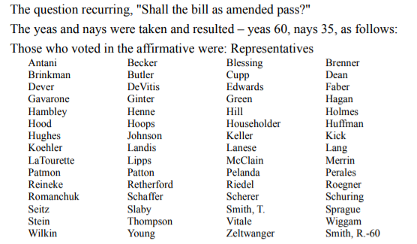

Ohio House Bill 228 eliminates any “duty to retreat” before using force in self-defense, shifts the burden of proof to the state in self-defense cases, and loosens a number of Ohio gun violence prevention rules -- including allowing individuals to challenge local gun violence prevention ordinances in court.

The roll call vote for HB 228, the “shoot first” or “kill at will” bill:

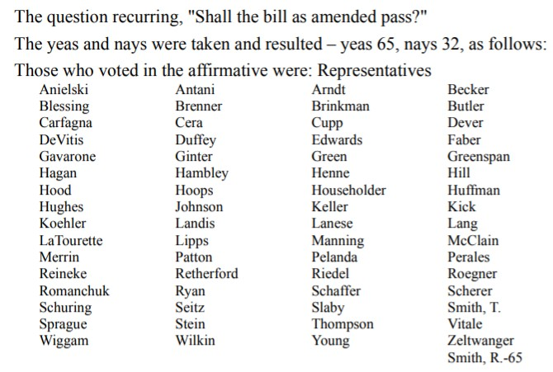
Paid for by the Ohio Democratic Party (http://ohiodems.org) and not authorized by any candidate or candidate's committee.

A MESSAGE FROM OUR FRIENDS AT INDIVISIBLE SPRINGFIELD

Indivisible Guide 2.0
National Indivisible has released a timely, new and downloadable Indivisible Guide 2.0 (go to https://indivisible.org/campaign/indivisible-whats-next?akid=.82.XPFQeS&rd=1&t=12 and scroll down). In 2016, the original Indivisible Guide rallied the grassroots against Trump’s agenda, declaring “Together we have the power to resist – and we have the power to win.” Now, in response to the 2018 Midterm Elections, the new guide proclaims partial success, but importantly maps out next steps:
Part One, Indivisible on Offense: A Practical Guide to the New, Democratic House, addresses the opportunities Democratic Congressional representatives will have for partial agenda-setting power, as well as the stiff spines they will need in face of pressure to “play ball” with Trump. Offensive strategies covered include the use of “Messaging Bills” and “Must-Have Bills,” as well as Congressional oversight hearings and investigations (with details on the relevant House and Senate committees and on the impeachment process). Defensive strategies included are withholding consent, filibustering, and denying quorum. As in the original guide, the role of constituents in influencing their representatives is critical – though this time, with a need for the more thorough knowledge of the workings of Congress that Part One of the guide helps provide.
Part Two, Indivisible States: Empowering the States to Resist the Trump Agenda, is of utmost importance to states such as Ohio, one of the “22 Republican trifecta states” identified by the guide as those in which “Republicans control both chambers of the legislature and the governorship.” Links in the online version to invaluable state-specific information assist with the nitty-gritty of defining a strategy and tactics to enable a state to win.
--Submitted by Melinda Barnhardt, WIN Liaison to Indivisible Springfield



NEWS, ISSUES AND ARTICLES
BIG PICTURE : Democrats flipped the House of Representatives and gained some pivotal governorships, while Republicans were able to keep control of the Senate, even picking up seats, in an unusually high turnout for a midterm election. With control of the House, Democrats have a check on President Trump’s power for the first time in his presidency. That means legislative gridlock, investigations, and potentially even impeachment. Source: New York Times
KEYSTONE PIPELINE: A federal judge has temporarily blocked construction of the Keystone XL Pipeline, dealing a blow to TransCanada which had been preparing to start building the oil pipeline in northern Montana. The decision to halt construction of the 1,184-mile pipeline allows for more time to study its potential environmental impact. Source: Great Falls Tribune
ONE TOUGH LADY: Supreme Court Justice Ruth Bader Ginsburg fractured three ribs after falling in her office on the evening of Wednesday, November 7th. The 85-year-old justice, a colon and pancreatic cancer survivor, was admitted to a hospital Thursday morning, November 8th for observation and treatment. Source: USA Today

SMOKING STATS: Smoking rates are at a record low in the U.S. The CDC says that in 2017, about 14 percent of adults smoked cigarettes--down from 15.5 percent in 2016, and 67 percent lower than it was in 1965 when the record-keeping began. Source: CNBC

FIRSTS: Alexandria Ocasio-Cortez, the progressive from New York, became the youngest woman ever elected to Congress. Rashida Tlaib in Michigan and Ilhan Omar in Minnesota are the first Muslim congresswomen. In Colorado, Jared Polis will be the first openly gay man elected governor. Source: Need2Know

- The Republican even a daughter can’t love: https://www.aol.com/article/news/2018/10/30/missouri-gop-candidates-daughter-dont-vote-for-my-dad/23576290/
- One year since the #MeToo Movement began: https://amp.usatoday.com/amp/1074976002
- Two Congolese, one a doctor and the other a released ISIS sex slave, awarded the Nobel Prize: https://www.nobelpeaceprize.org/The-Nobel-Peace-Prize-2018
- Australia set to be the first country to eliminate Cervical Cancer: https://www.bbc.com/news/amp/world-australia-45727977
- Bill Bradley deconstructs Trump’s take on sports: https://www.msn.com/en-us/sports/nba/bill-bradley-concisely-deconstructs-donald-trump’s-use-of-sports-to-divide/ar-BBNKMlp?ocid=spartandhp


WONDER WOMEN!
- Singer and song-writer Rebecca Moreland has turned great pain into great hope. At 21, she entered a marriage that would turn abusive. She’s since found the strength to move and channel that dark time into her lifelong passion: music. She is now a voice for others in similar situations and volunteers and performs all around the world.
- Wife, mother and entrepreneur Megan Hunt is the founder of “Safe Space of Nebraska,” a non-profit dedicated to fighting the epidemic of sexual harassment and assault in the nightlife culture. Ms. Hunt not only wears all these hats, but was just elected to the Nebraska State Legislature, 8th Omaha District, and is the first openly bisexual person to fill that seat.
- When your parents are co-founders of the successful company, Seventh Generation, caring about the environment is kind of in your blood. So, it comes as no surprise that Meika Hollender has decided to carve her own path in the sustainable living space. Enter: her company “Sustain Natural”—a sexual-wellness brand that produces a range of natural products, including 100 percent organic cotton pads and tampons, as well as vegan and cruelty-free condoms and lube.
- This fall actress and producer Miranda Bailey founded a women-driven version of Rotten Tomatoes named “The Cherry Picks,” which critiques and rates films from a feminist perspective.
- In late 2017, the other NRA--The National Restaurant Association-- partnered with President Trump to try to make tips the property of owners rather than workers. An organization named “Restaurant Opportunities Centers United” mobilized 400,000 restaurant workers, employers and consumers to win a bipartisan bill in Congress that protects tips as the property of workers, now and forever. The founder of that organization, Saru Jayaraman, an attorney and child of Indian immigrants, delights in being called “difficult,” because as such she knows she is strong.

A)   | B)  
C)   | D)  
E)  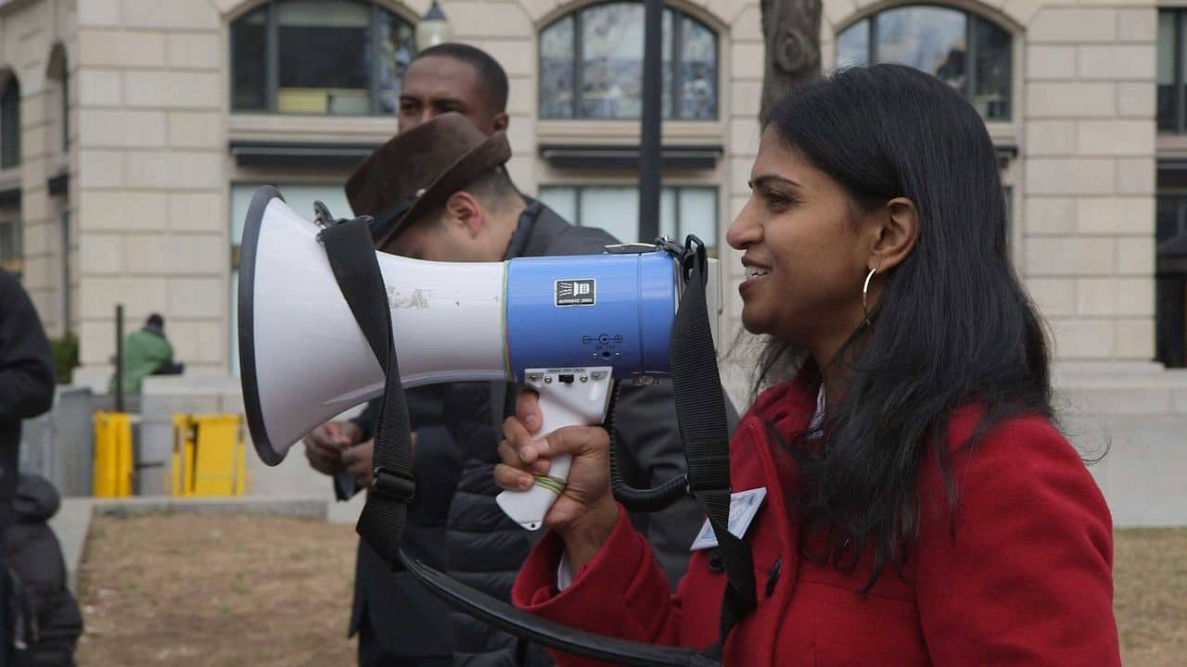 | 
BOOK LOOK:

Reading suggestions for books written by, for, or about strong women
Fiction:
- In Transcription by Kate Atkinson, a London woman is targeted by the operatives she spied on for M15 during WW II ten years before.
- Goodbye, Vitamin by Rachel Khong is a novel with a gorgeous meditation on family, responsibilities, memory, and understanding one's place in life.
- Daughter of a Daughter of a Queen, by Sarah Bird, is a fascinating work of historical fiction about Cathay/Cathy Williams, a former slave turned Buffalo Soldier in post-Civil War America.
- The Great Alone by “Nightingale” author Kristin Hannah describes a girl’s coming-of-age in the wilds of Alaska fighting dangers both from outside her home and inside.
- The Big Book of Female Detectives, edited by Otto Penzler, features 74 short stories from such mystery writers as Agatha Christie, Sue Grafton, Anne Perry, Joyce Carol Oates, and many more.
Non-Fiction:
- The Last Girl is Nobel Prize winner Nadia Murad’s intimate and harrowing memoir of survival as a former slave of the Islamic State in the Congo.
- The Big Fix: Hope After Heroin is Tracey Helton Mitchell’s 2016 memoir that chronicles the decade she spent addicted to heroin and on the streets of San Francisco’s Tenderloin district, as well as her eventual recovery and subsequent life as a mother of three and PTA treasurer.
- Enlightenment Now by Steven Pinker makes the brilliant case for reason, science and humanism: the ideals we need to confront our problems and continue our progress.
- Becoming by Michelle Obama is an intimate, powerful and inspiring memoir of the former First Lady of the United States
- Ruth Bader Ginsberg by Jayne Sherron DeHart is the first full life biography—private, public, legal, philosophical—of the 107th Supreme Court Justice, one of the most profound and profoundly transformative legal minds of our time
For tons of Holiday gift book suggestions for readers of every age and genre, go to this website: https://www.readitforward.com/specials/gift-guide-2018/



COMMUNITY CALENDAR

Dec. 3: Hanukkah Begins
Dec. 7: Pearl Harbor Day
Dec. 21: First Day of Winter
Dec. 24: Christmas Eve
Dec. 25: Christmas
Dec. 26: Boxing Day
Dec. 26: Kwanzaa
Dec. 31: New Year’s Eve

Jan. 1: New Year’s Day
Jan. 9: WIN Meeting, 6 PM, Rooms 1 & 2 of Main Library, downtown*
Jan. 21: Martin Luther King Day

*Once again, WIN will be doing a community service project in memory of Dr. Martin Luther King, and are requesting that all members participate. We will be collecting women’s toiletry items to donate to the Free Store on Selma Road. Mainly to be collected are women’s sanitary items, such as tampons, pads, toilet paper, wipes, etc. However, the Free Store is also in need of dental (toothbrushes, toothpaste, mouthwash, etc) and general hygiene items (soap, deodorant, shampoo, facial tissues, etc.) Please bring your donations to our meeting on January 9th.



Victory News Readers:
If you would like to publicize an upcoming event, make an announcement, suggest a relevant book to read, or contribute an article to the next issue of Victory News, please get it to me by Friday, January 25, 2019. You may contact me one of these ways:
- E-mail: bwillman952@aol.com
- Phone: 937-917-8032
- Address: 1828 Berwick Ave., Springfield 45503

In addition, I am always open to feedback about this issue and/or suggestions for improving future newsletters. Thanks for reading!
Becky Willman, Victory News Editor

December 3, 2018
Dear Current and Potential WIN Members:

Welcome to the 2019 Clark County Democratic Women’s Issues Network, otherwise known as the WIN. Whether you are a recent, potential, or continuing member, we look forward to your participation in this new and critical moment in advance of 2020.

As many of you know, the WIN and its predecessor, the WIGS, were formed as a forum for Democratic women to get together to discuss politics in an intelligent and friendly manner – and to socialize. Today, The WIN is comprised of progressive Democrats--both women and men--who share our views on numerous matters that concern us all: health care, children’s issues, pay equity, gender equity, jobs, education, minority equality, protecting our environment, and other issues as they arise. We also plan one or more educational events per year to educate the public about our concerns or to celebrate women’s accomplishments, past or present.

Additionally, the WIN raises money for candidates it supports. We are a State of Ohio Political Action Committee, fundraising for candidates in local and statewide races, and with some restrictions, for candidates for federal office. Since our inception in 2009, we have been proud to contribute in excess of $20,000.00 to Democratic candidates. We have gained a statewide reputation as prolific fundraisers and dedicated workers for Democratic Issues and causes. This is gratifying work!

Elections for the positions of president, treasurer, deputy treasurer, recording secretary, and membership chair will be held at our next meeting, on Wednesday, January 9, 2019, at 6 p.m., Rooms 1 and 2, in the Clark Co. Public Library.* Nominating committee members Sue Allen (937 324-8676) and Cathy Tuckerman (937 390-3609) have prepared a slate of candidates. However, anyone additional who wishes to run can contact them, and nominations will also be possible from the floor. Feel free to contact me for any questions you might have. We do hope to see you!

Sincerely,

Rebecca Willman, Corresponding Secretary

bwillman952@aol.com
(937) 917-8032

*2019 Dues are $20.00 and payable at the January 9th meeting. If you are a new member, please print and fill out the form on the next page and bring it with you that evening, along with your dues. If you cannot attend, please send the form and your dues to Austin Smith, at the address below.

Paid for by the Democratic Women’s Issues Network, not authorized by any candidate or candidate’s committee. Austin Smith, Interim Treasurer, 3214 Revels St., Springfield, OH 45503. Contributions are subject to the limits and prohibitions of the Federal Election regulations. Contributions to the Women’s Issues Network are NOT tax deductible as charitable contributions for Federal Income Tax purposes. Created in-house. Labor and materials donated.

Join WIN!  Membership in the WIGS is open to Democratic women and men.  Mobilize and take action on issues that impact you, your family, and your community.  I want to:  ___ Enjoy the company of  like-minded progressives  ___ Help raise money  ___ Lobby for women’s issues  ___ Plan and/or present programs  ___ Recruit new members  ___ Run for political office  ___ Serve on WIGS Steering Committee  ___ Work on campaigns  ___ Other (specify): _______________  ________________________________ | WIN  MEMBERSHIP APPLICATION  Complete these two panels and mail the completed application and $20.00 annual dues to: Austin Smith, 3214 Revels St., Springfield, OH 45503  Name: ______________________________  Address: ____________________________  _________________________________  City: _______________________________  State: ____________________ Zip: ______  Phone: _____________________________  Email: ______________________________  Occupation (required):  ___________________________  __________________________________________________

Paid for by the Democratic Women’s Issues Network, Austin Smith, Treasurer, Springfield, OH 45503. Contributions are subject to the limits and prohibitions of the Federal Election regulations. Contributions to the Women’s Issues Network are NOT tax deductible as charitable contributions for Federal Income Tax purposes. Created in-house. Labor and materials donated.

