Women’s Issues Network (WIN)  VICTORY NEWS  August/September, Volume 3, Issue 4  Editor: Rebecca S. Willman  Clark County/Springfield, Ohio | 

A MESSAGE FROM OUR PRESIDENT…

This is supposed to be the "dog days of summer🐕". It's anything but!
There’s only 72 days until early voting begins and 100 days until the general election. That’s not very long to work until we Dems can get what we want--a tsunami of Blue representatives in both Congress and the Statehouse.
Here lies the question we need to ask ourselves: “Do I vote a straight Democratic ticket to ensure a Blue Wave on November 6th or will I vote willy-nilly for candidates across the political spectrum just because I want to exercise my right to choose?”
I've picked up some flack about this statement and I can only reiterate that it is critical that Dems send Trump—and what is charitably now called the GOP--a stern message. We must hang together as a solid group. Do you want “Twumpie” to continue to run amok over our Constitution and institutions while continuing his traitorous relationship with Putin, or do we curb his power? Only “We the People” can do that. The GOP is successful because they are party-loyal and we've all seen it in action in Congress by Jordan, Davidson, Turner, etc. This blinker-blind loyalty holds sway no matter what.
To ensure a November victory we all must be loyal to the Democrats on the ticket. We owe them at least that for their bravery and resourcefulness in working to bring about much-needed change.
Now on to a lighter subject: “August Nights!”
We have a great slate of candidates that will be in attendance, and we’ve made a couple of exciting changes to the event. One change is the beautiful new indoor venue on the grounds of the Ohio Masonic Home which will allow us to enjoy the evening come rain or heat. Instead of a keynote speaker, we will give the candidates a chance to answer YOUR questions in a Q & A session after dinner. It will be a chance to hear something other than a stump speech. They will begin their presentations about 6:30 PM, take Q & A from 6:45-7 PM and then will meet and greet with you.
Directions to the Festival Green Club House are below:
When you enter the Masonic Home campus, bear left and take Lower Loop Road. Follow it all around until you see a big parking lot--Festival Green Club House is there. There will be event parking signs to help.

I look forward to meeting everyone at this event! --Cheri



WIN welcomes these new and returning members:

- Kent Brooks

- Kathy Estep
- Sheila Drennen
- Rick Incorvati
- Brad Minerd
- Alex Wendt

BUSY SUMMER FOR THE WIN TEAM
The summer of 2018 has been especially busy for us this year, and it’s not over yet! Here are the events so far that we have either sponsored or taken part in since June 1st:
- Hosted the “A – to – Z” Fundraiser for Amanda Finfrock and Zack Space (June 14th)
- Helped staff Amanda’s booth at the Pride Festival (June 30th)
- Helped Amanda’s campaign by phone-calling and canvassing
- Attended the Democratic Club’s Candidate Night—Keynote Richard Cordray (July 12th)
- Hosted a luncheon for Melody Smith and Vanessa Enoch (July 18th)
- Helped staff the Dem Booth at the Clark County Fair (July 20 – 27th)
- Attended a house party for Amanda (July 28th)
- Currently preparing for our “August Nights” Fundraiser

WIN salutes and supports these Ohio Democrats running for office in November:
- Amanda Finfrock: State Rep 79th District (WIN Member)
- Anne Gorman: State Rep 74th District (WIN Member)
- Melody Stewart: Ohio Supreme Court
- Vanessa Enoch: 8th Congressional District
- Zack Space: State Auditor
- Steve Dettlebach: State Attorney General
- Kathleen Clyde: Ohio Secretary of State
- Richard Cordray: Ohio Governor
- Betty Sutton: Ohio Lt. Governor
- Sherrod Brown: U.S. Senate

Amanda Finfrock Zack Space
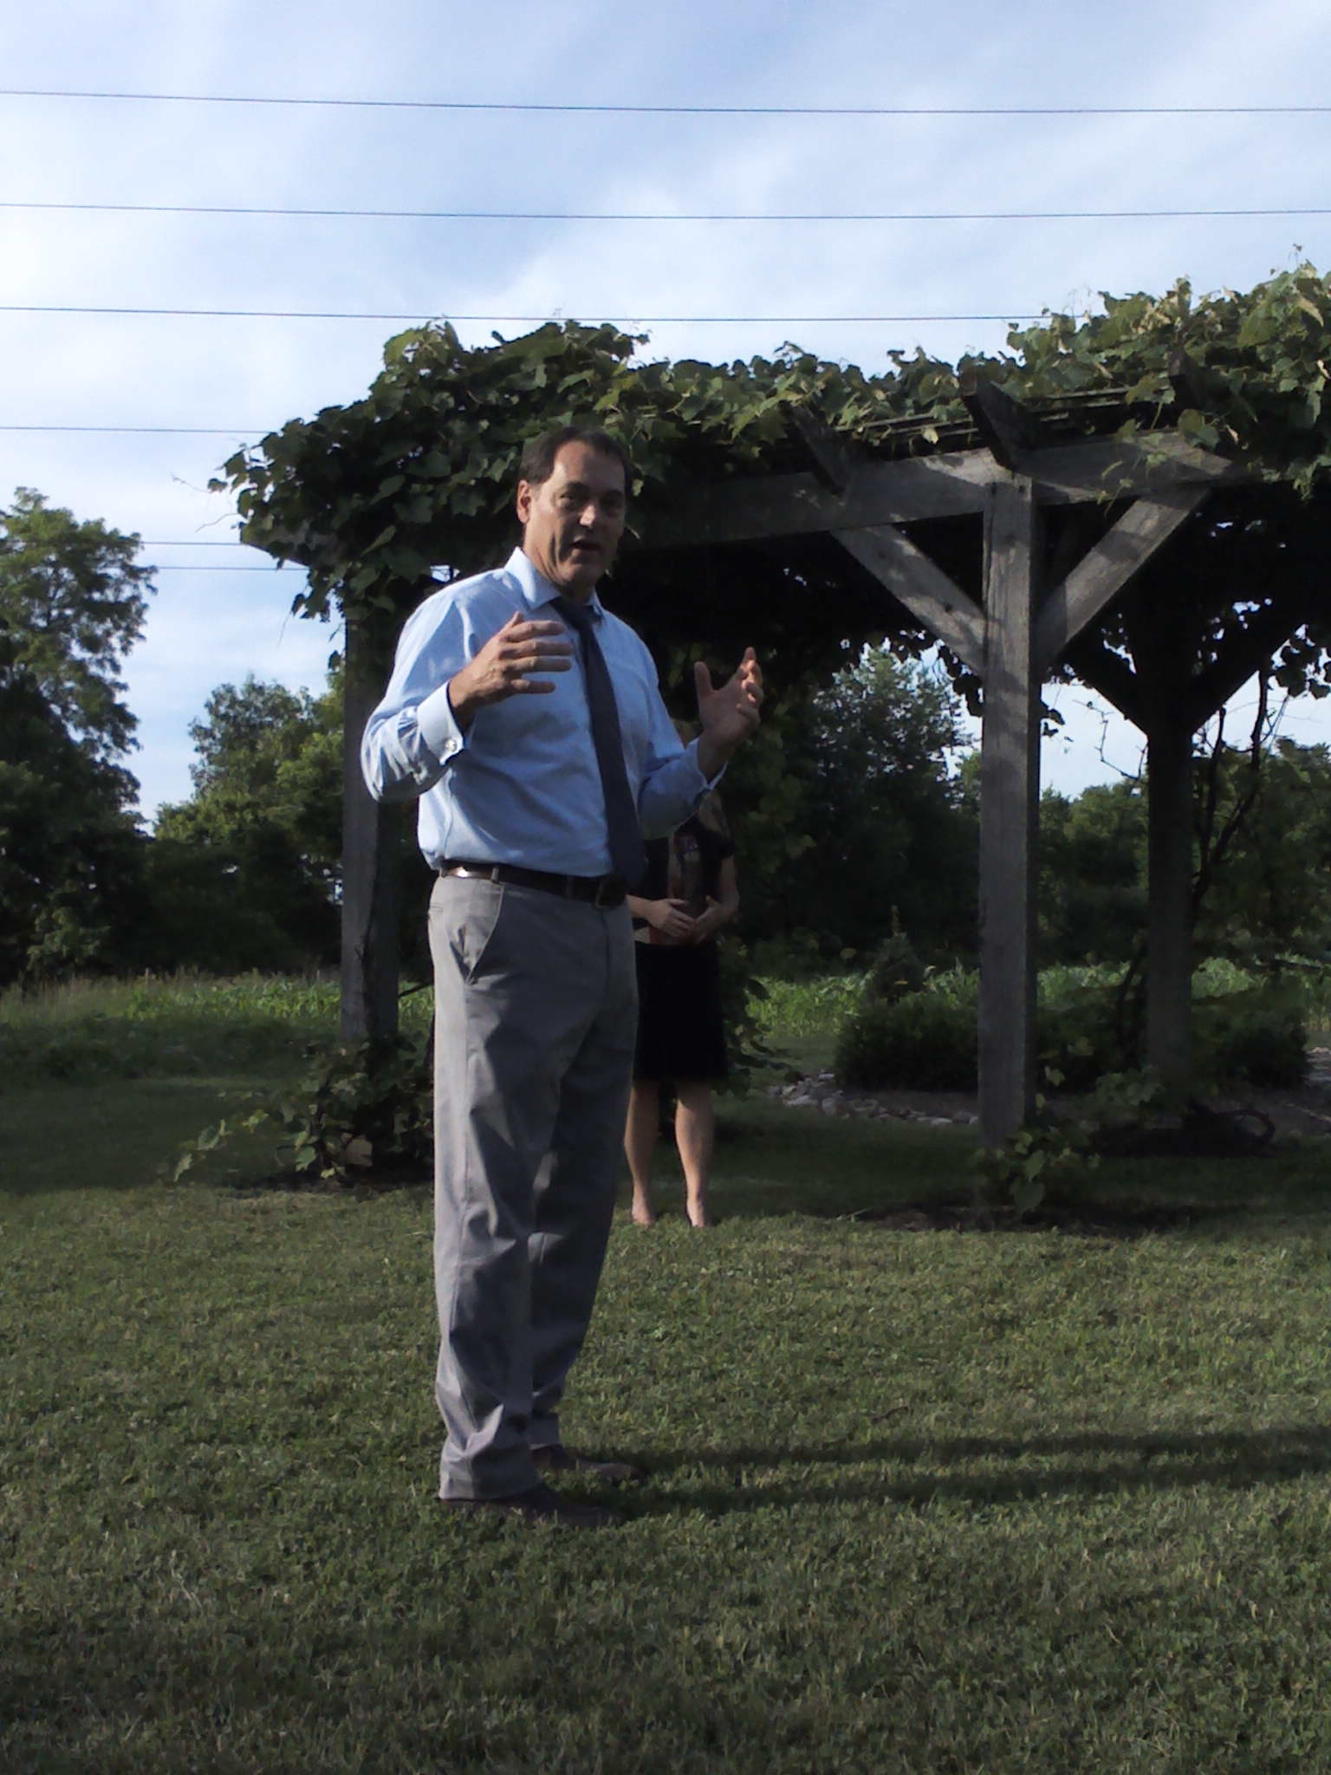
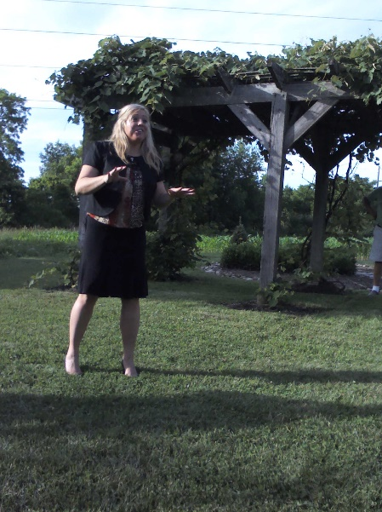

“A – TO – Z FUNDRAISER” AT THE HOME OF SUE ALLEN ON JUNE 14, 2018
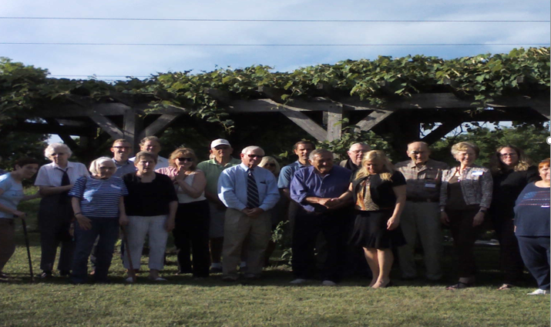

LUNCHEON FOR MELODY STEWART AND VANESSA ENOCH AT O’CONNORS ON JULY 18TH
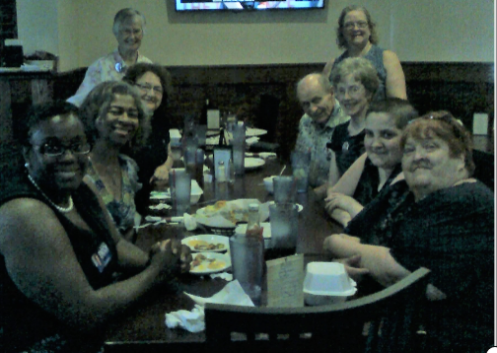

Clockwise from lower left: Vanessa Enoch, Jean Harper, Joetta Cooper, Clara Copeland, Sue Allen, Hank & Melinda
Barnhardt, Jessica Crothers, Cheri Crothers

DEMOCRATIC CLUB CANDIDATE NIGHT, JULY 12TH
(All photos on this page, courtesy of Anne Gorman. Thanks, Anne!)

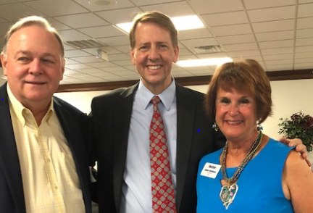
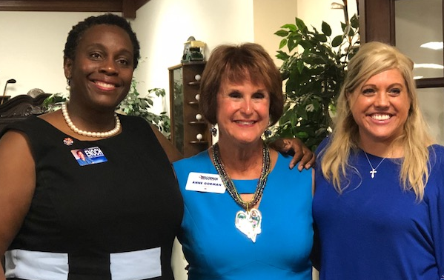

Vanessa Enoch, Anne Gorman, Amanda Finfrock Center: Dem Candidate for Governor Richard Cordray

CLARK COUNTY FAIR, JULY 20 – 27TH

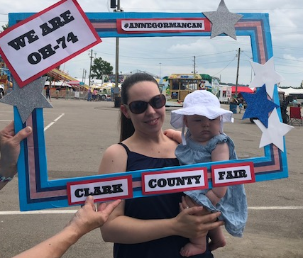

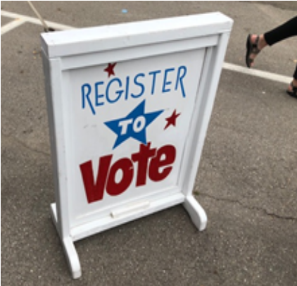

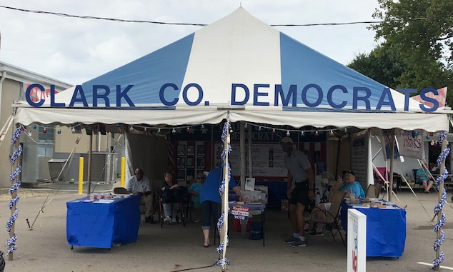
ISSUES AND ARTICLES
3-D PRINTED GUNS
A federal judge has temporarily blocked the release of downloadable blueprints for 3D-printed guns. The order comes as eight states are suing the Trump administration over its decision to let a Texas company publish the blueprints online. Officials say that 1,000 people have already downloaded blueprints for AR-15 rifles.
SOURCE: TIME Magazine

BY THE NUMBERS: Officials said Thursday night that 1,820 children had been reunited with their parents, but 711 are still in custody because their relatives have been deemed “ineligible” for reunification. More than 400 of these children reportedly have parents who may have already been deported. SOURCE: CBS News
WHAT’S AT STAKE IN NOVEMBER ELECTIONS NATIONWIDE:
- 36 gubernatorial races
- 30 attorney general elections
- 87 state rep positions in 46 states
- 6,000+ state legislative seats up for grabs
- More than 800 of those seats will be responsible for redrawing congressional maps in 2021 SOURCE: DNC
- The Trump Foundation Scandal: https://www.cnn.com/2018/06/16/opinions/trump-foundation-scandal-opinion-snell/index.html

- Trump and Putin vs. America: http://www.eastoregonian.com/eo/columnists/20180716/friedman-trump-and-putin-vs-america

- What a Russian spy, the NRA and a National Prayer Breakfast have in common: https://www.msn.com/en-us/news/us/butina-arrest-6-things-to-know/ar-AAAaRJb?ocid=spartandhp

- Climate Change: https://fivethirtyeight.com/features/what-climate-change-looks-like-in-2018/

- The hard truth about the Mueller investigation: https://www.cnn.com/2018/07/31/politics/donald-trump-rudy-giuliani/index.html

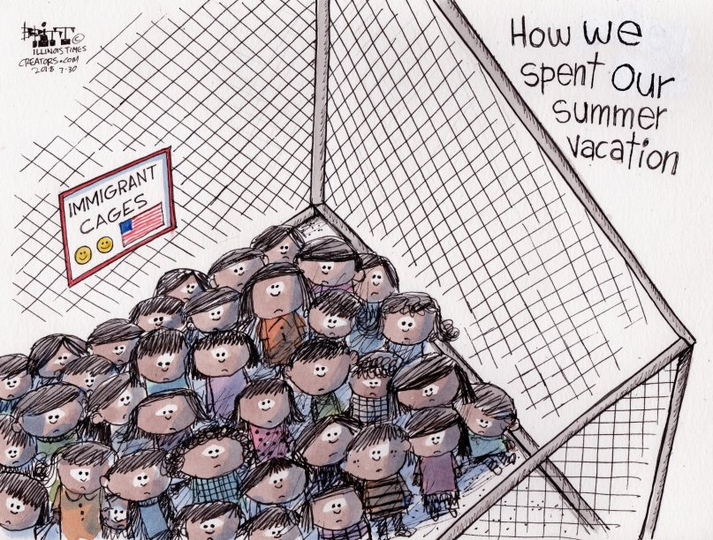

WONDER WOMEN!
SAN FRAN FIRST
San Francisco just elected its first African American woman mayor, London Breed. She was the Board of Supervisors president for the city. In her victory speech, Breed talked about growing up in public housing in the city, saying, "Never let your circumstances determine your outcome in life."
SOURCE: NPR
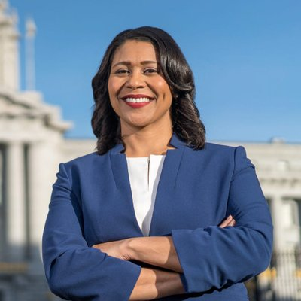

ON HER WAY
Alexandria Ocasio-Cortez defeated the incumbent in the New York Democratic Primary for U.S. Congress, representing NYC District #14. Alexandria has a working-class background and champions families struggling to make ends meet. If elected, she will be the youngest woman elected to Congress.
SOURCE: DNC


MISS REBEL AMERICA
A contestant in a state-level Miss America competition returned her Miss Plymouth County crown last month after a host of the Miss Massachusetts pageant mocked the #MeToo movement. Maude Gorman was gang-raped at the age of 13 and struggled for years with PSTD before entering the pageant circuit, where she was an outspoken advocate for sexual assault victims. Maude says she is done with pageants for good. SOURCE: CREDO ACTION


BOOK LOOK:
Reading suggestions for books written by or about strong women
Fiction:
- Small Great Things by Jodi Picoult is a gripping novel about race in America that not only delivers a
compelling courtroom drama, but a scathing commentary on today’s social climate.

- The Last Ballad by Wiley Cash pays tribute to the thousands of heroic woman and men who risked their lives to win basic rights for all workers, using the story of a single mother fed up with slavish employment at a textile mill in 1929 North Carolina.

- Vox, by Christina Dalcher, is set in a future America where half its citizens have been silenced and one
woman will do whatever it takes to protect herself and her daughter.

- In Sharon Bolton’s thriller, Dead Woman Walking, a woman who is the lone survivor of a hot-air balloon crash over the vast moors of northern England must use all the survival skills she knows to elude the man who shot it down and wants to leave no witnesses.
Non-Fiction:
- Educated is Tara Westover’s memoir of earning a PhD from Cambridge University despite having been raised by survivalist parents who denied her a formal education.

- In The Monarchy of Fear, acclaimed scholar and humanist Martha C. Nussbaum turns her attention to the current political crisis that has polarized America.*

- Squeezed: Why Our Families Can’t Afford America, by Alissa Quart, examines a subject that most
people shy away from discussing—money and class.

- Amity and Prosperity, by Eliza Griswold, explores our nation’s ill-advised zeal for exploiting our abundant natural resources as promoted by rapacious corporations.

*
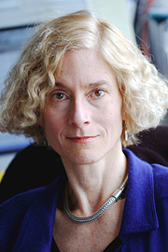
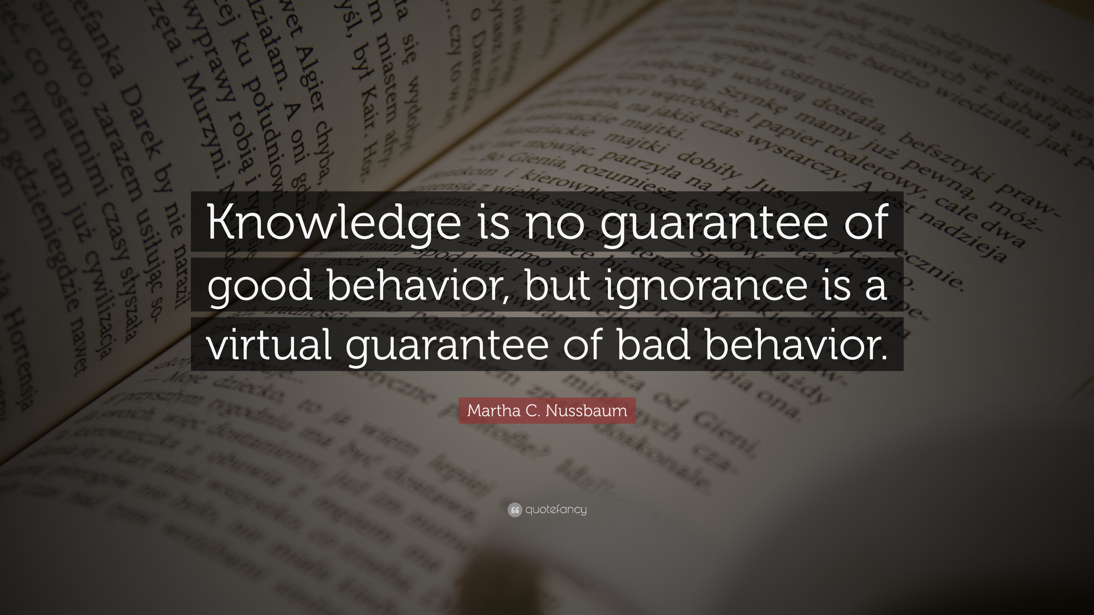

COMMUNITY CALENDAR
Aug. 7: Equality Springfield Meeting, Christ Episcopal Church, 7 PM
Aug. 9: WIN Meeting @ home of Cheri Crothers, 5:30 PM
Aug. 16: WIN “August Nights” Fundraiser @ Ohio Masonic Home Clubhouse, 5:30 PM
Aug. 21: Springfield Indivisible Meeting @ First United Church of Christ, 6:30 PM
Sept. 3: LABOR DAY
Sept. 4: Equality Springfield Meeting, Christ Episcopal Church, 7 PM
Sept. 9: Grandparents’ Day/Rosh Hashanah Begins
Sept. 11: Patriot Day
Sept. 13: WIN Meeting, 5:30 PM (Location TBA)
Sept. 18: Springfield Indivisible Meeting @ First UCC, 6:30 PM
Yom Kippur Begins
Sept. 19: CCDP Central Committee, 6:30 PM/Executive Committee, 7:30 PM @ Local #402
Sept. 21: International Day of Peace
Sept. 22: Culture Fest, Downtown Springfield, 11 AM to 6 PM

Victory News Readers:
If you would like to publicize an upcoming event, make an announcement, suggest a relevant book to read, or contribute an article to the next issue of Victory News, please get it to me by Saturday, September 29th. You may contact me one of these ways:
- E-mail: bwillman952@aol.com
- Phone: 937-917-8032
- Address: 1828 Berwick Ave., Springfield 45503

In addition, I am always open to feedback about this issue and/or suggestions for improving future newsletters.
Thanks for reading!
Becky Willman
Victory News Editor

Dear Victory News Reader,
The Democratic Women’s Issues Network has made a change in its Membership Policy to reflect the ever-changing roles of both women and men in our society.
More and more demands are made of our time which--for many of us--is already divided between work, family and other duties. It’s always that “one more thing” someone or some group asks of you, and you just don’t have the time to give. For some of us, health issues may prevent active participation. The WIN realizes that many of you like the work we do to in promoting Democratic candidates and educating the public about issues that affect women. WIN has added a new Membership category to reflect this time press we all feel. The new category is: Supporting Membership.
A SUPPORTING MEMBER would join WIN just like an Active Member. You will receive our newsletter, event announcements and other communications. You will not be required to attend meetings or to work at events unless you would like to do so. By financially contributing to the WIN, you will be aiding us in recruiting, training and electing qualified progressive Democrats for public office at all levels.
The next step is easy. Print and fill out the membership form on the next page and mail it back to us along with your $20 yearly dues, or just hand them to me at the next WIN event. Then you will be added to our membership roster as a valued supporter of our vital organization.
In closing, we thank you for your support, and want you to know that you will always be welcomed.
Sincerely,
Cheri Crothers
Cheri Crothers, President
Clark County Democratic Women’s Issues Network

The 2018 WIN Board Members are:
- President: Cheri Crothers
- Vice President: Sue Allen
- Corresponding Secretary/Newsletter Editor: Becky Willman
- Treasurer: Austin Smith
- Deputy Treasurer/Fair Coordinator: Cathy Tuckerman
- By-Laws/Nominations Chair: Janet Click
- Indivisible Liaison: Melinda Barnhardt
- Equality Liaison: Jessica Crothers
- Media Liaison: Cynthia Dunlevy

Join WIN!  Membership in the WIGS is open to Democratic women and men.  Mobilize and take action on issues that impact you, your family, and your community.  I want to:  ___ Enjoy the company of  like-minded progressives  ___ Help raise money  ___ Lobby for women’s issues  ___ Plan and/or present programs  ___ Recruit new members  ___ Run for political office  ___ Serve on WIGS Steering Committee  ___ Work on campaigns  ___ Other (specify): _______________  ________________________________ | WIN  MEMBERSHIP APPLICATION  Complete these two panels and mail the completed application and $20.00 annual dues to:  Cheri Crothers, 1235 Torrence Dr.  Springfield, OH 45503  Name: ______________________________  Address: ____________________________  _________________________________  City: _______________________________  State: ____________________ Zip: ______  Phone: _____________________________  Email: ______________________________  Occupation (required):  ___________________________  __________________________________________________

Paid for by the Democratic Women’s Issues Network, Cheri Crothers, Treasurer, 1235 Torrence Dr., Springfield, OH 45503. Contributions are subject to the limits and prohibitions of the Federal Election regulations. Contributions to the Women’s Issues Network are NOT tax deductible as charitable contributions for Federal Income Tax purposes. Created in-house. Labor and materials donated.

THANKS FOR READING! SEE YOU IN OCTOBER…………

